**HEATING CYCLE 1**

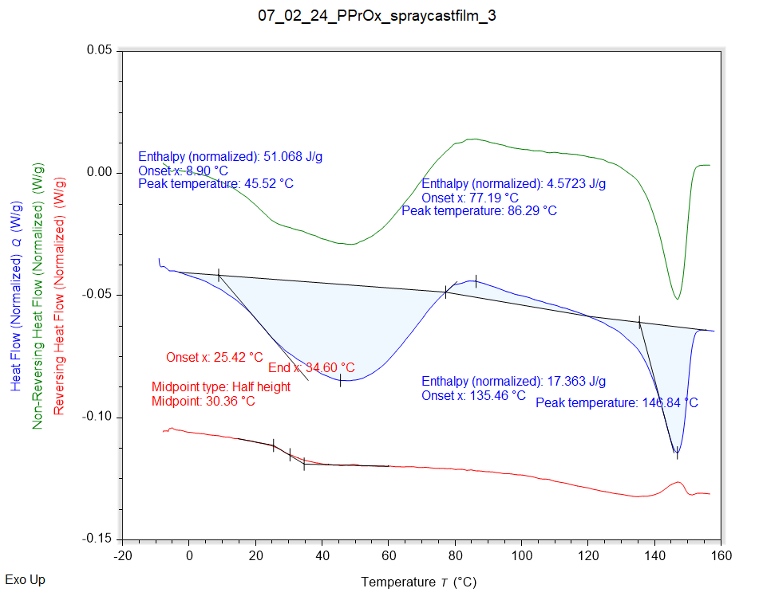

|  |  |  |  |
| --- | --- | --- | --- |
| Solvent HC1 | Peak Onset | Peak Location | Enthalpy |
|  | 8.899 °C | 45.524 °C | 51.068 J/g |

|  |  |  |  |
| --- | --- | --- | --- |
| Recrystallisation HC1 | Peak Onset | Peak Location | Enthalpy |
|  | 77.188 °C | 86.294 °C | 4.5723 J/g |

|  |  |  |  |
| --- | --- | --- | --- |
| Melting HC1 | Peak Onset | Peak Location | Enthalpy |
|  | 135.459 °C | 146.841 °C | 17.363 J/g |

|  |  |  |  |
| --- | --- | --- | --- |
| Tg HC1 | Onset | Midpoint | End |
|  | 25.419 °C | 30.361 °C | 34.602 °C |

**HEATING CYCLE 2**

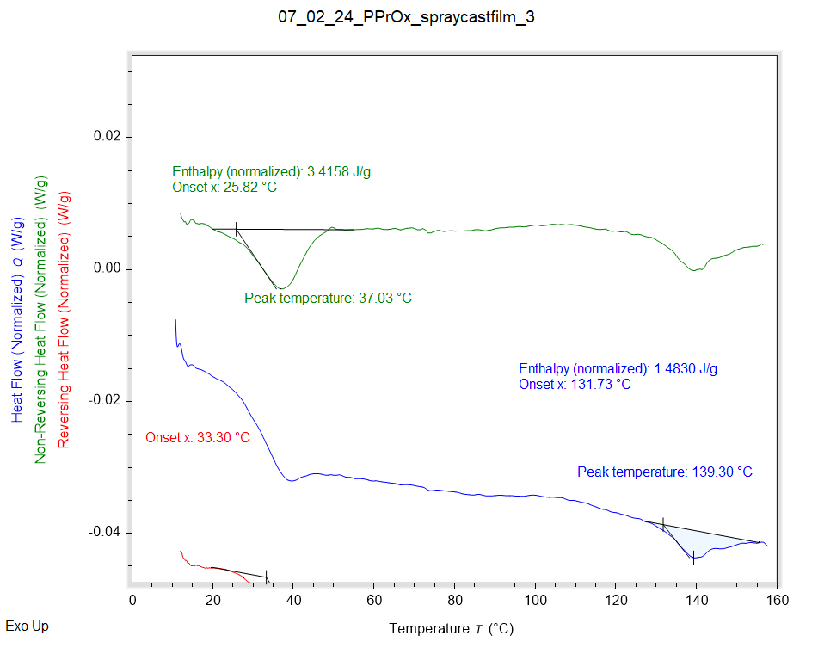

|  |  |  |  |
| --- | --- | --- | --- |
| Solvent HC1 | Peak Onset | Peak Location | Enthalpy |
|  | 25.821 °C | 37.027 °C | 3.4158 J/g |

|  |  |  |  |
| --- | --- | --- | --- |
| Melting HC1 | Peak Onset | Peak Location | Enthalpy |
|  | 131.245 °C | 139.212 °C | 1.5785 J/g |

|  |  |  |  |
| --- | --- | --- | --- |
| Tg HC1 | Onset | Midpoint | End |
|  | 33.303 °C | 39.561 °C | 45.798 °C |

**HEATING CYCLE 3**

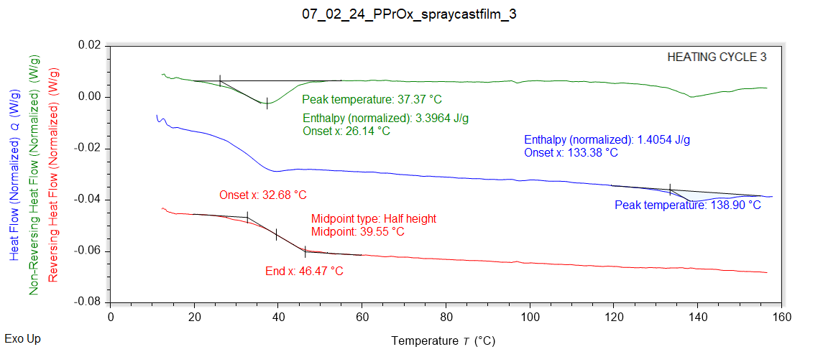

|  |  |  |  |
| --- | --- | --- | --- |
| Solvent HC1 | Peak Onset | Peak Location | Enthalpy |
|  | 26.144 °C | 37.370 °C | 3.3964 J/g |

|  |  |  |  |
| --- | --- | --- | --- |
| Melting HC1 | Peak Onset | Peak Location | Enthalpy |
|  | 133.385 °C | 138.898 °C | 1.4054 J/g |

|  |  |  |  |
| --- | --- | --- | --- |
| Tg HC1 | Onset | Midpoint | End |
|  | 32.677 °C | 39.555 °C | 46.467 °C |